Wer bist du? ……….ein Fragebogen
Ich heiße _____________. Mein Lieblingstier (favorite animal) ist _________________.
Ich komme aus _____________. (I am from...) Mein Lieblingsland (favorite country) ist _______________.
Warum machst du Deutsch? Why are you taking German? (Do not only say because a foreign language is required...if this is the case, why are you taking German rather than Spanish?)
______________________________________________________________________________________________________________________________________________________________________________
Warum ist Deutsch für dich interessant? (Why do you find it interesting?)
______________________________________________________________________________________________________________________________________________________________________________
Ich mache (play/do) Sport: ja----nein
Wenn ja, welches Sport? ____________________
Bist du in einem Klub? Ja-----nein
Wenn ja, welcher Klub? ______________________
Do you have any worries, fears, or anything you are super excited about this year?
______________________________________________________________________________________________________________________________________________________________________________
Likes and dislikes? Strengths and weaknesses?
______________________________________________________________________________________________________________________________________________________________________________
Is there anything else I should know about you in general, or in order to best help you learn? For example, What motivates you? Do you have test-taking anxiety? Do you have six siblings and little time to do homework? Have you ever learned German before or have German heritage? Etc.
_____________________________________________________________________________________________________________________________________________________________________________________________________________________________________________________________________
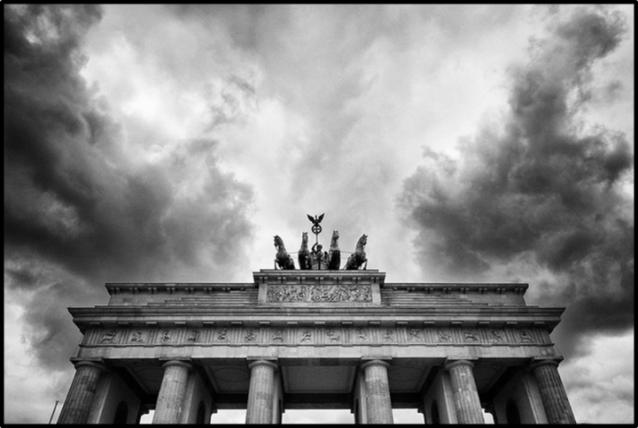
Vielen Dank!!!! Und viel Spaß dieses Jahr
-----Frau Ehnle

